# Michael Chillemi

# 06/28/2023

# CS 590 - Algorithms

# M6.B1: Module 6 Union-Find Structures Reinforcement Exercises

Problem 7.5.1

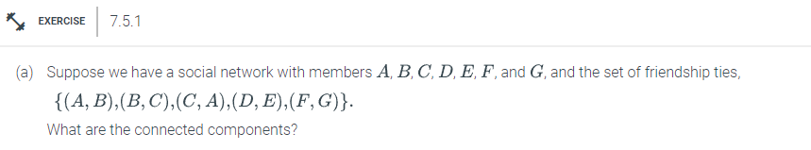

Answer:

In this socal network problem each member is represented as a node A,B,C,D,E,F,G. Using the set of friendship ties listed in the problem we can draw out the connected components as such:



The Connected Components Are: {(A,B,C) , (D,E), (F,G)}

Problem 7.5.2

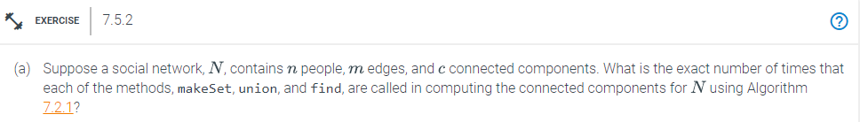

Answer:

If n represents a singleton set, the union() operation will execute roughly (log n) times, and find() and makeSet() will each execute n times. As a small example if **N** is equal to 100 then the find function and makeset function will run for 100 times. But the union function will only run twice.